Dynamic Year™
A Three Step Program to Build the Foundation for this Year
- First step: Reflect on your accomplishments and disappointments
- Second step: Wisdom: Find learning in what you experienced
- Third Step: Guidelines: We’ll look at the 1st and 2nd steps, create clear guidelines to set up success.

Module One (Part 1): Reflect on your accomplishments
Why do we look at past success?
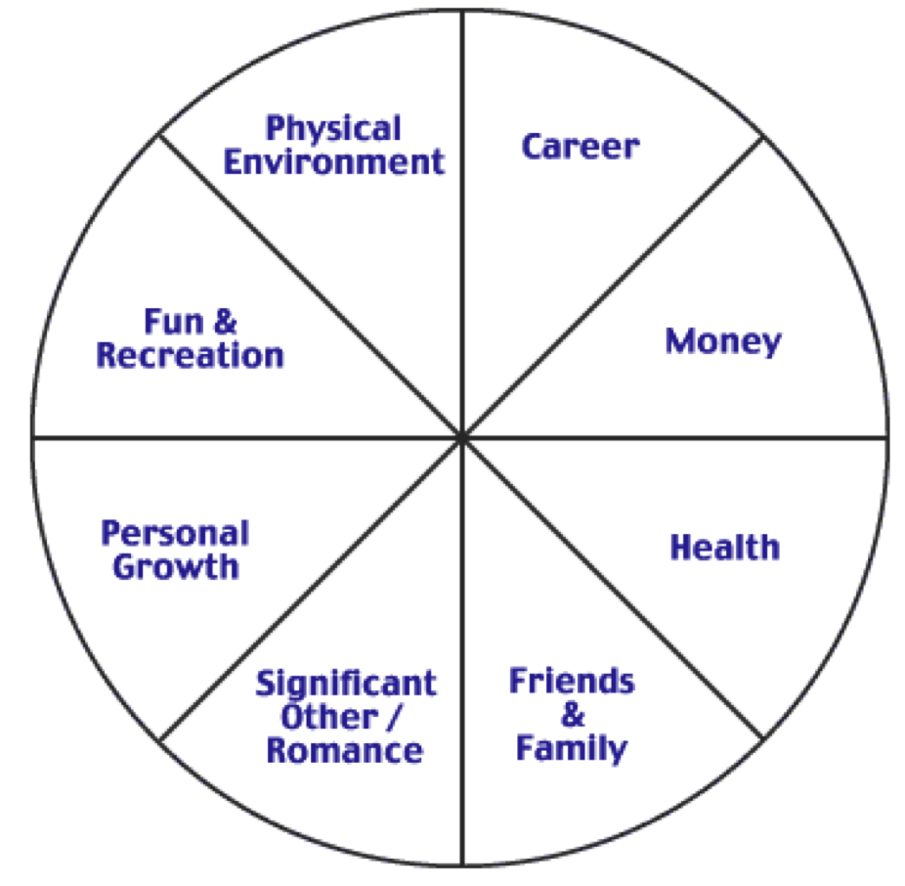

What were your most significant accomplishments last year?
In your professional life | 1.  2.  3.  4.  5.
With fun and recreation | 1.  2.  3.  4.  5.
With your finances | 1.  2.  3.  4.  5.
With your friends | 1.  2.  3.  4.  5.
With your family | 1.  2.  3.  4.  5.
With your health | 1.  2.  3.  4.  5.
In your physical environment | 1.  2.  3.  4.  5.
With your Significant other | 1.  2.  3.  4.  5.
In your personal development | 1.  2.  3.  4.  5.
Anything else | 1.  2.  3.  4.  5.

Go Deeper: Go ask a loved one, a friend or a colleague what they think your accomplishments were in the different areas and start adding to your list. If they mentioned something you already wrote down then you can put a star beside it.

Skill: Acknowledgement
How do you do it? What is an acknowledgement you can give yourself?

Module One (Part 2): Reflect on your disappointments
Why do we look at past disappointments?
What were your biggest disappointments from last year?
In your professional life | 1.  2.  3.  4.  5.
With fun and recreation | 1.  2.  3.  4.  5.
With your finances | 1.  2.  3.  4.  5.
With your friends | 1.  2.  3.  4.  5.
With your family | 1.  2.  3.  4.  5.
With your health | 1.  2.  3.  4.  5.
In your physical environment | 1.  2.  3.  4.  5.
With a Significant other | 1.  2.  3.  4.  5.
In your personal development | 1.  2.  3.  4.  5.
Anything else | 1.  2.  3.  4.  5.

Go Deeper: Find someone to share your disappointments with. Tell them in advance that you just want to clear them out and don’t need any advice, empathy or problem solving.

Skill: Clearing
How do you do it? Why do we do it?

Practice the skills of acknowledging and clearing. Fill in all of the handouts and schedule the time in your calendar to work on the next modules.

Have questions or comments? Send them to me at diane@dianerolston.com.

